

Faculty of Computer Science and Mathematics

Universiti Malaysia Terengganu

LAB REPORT

CSE3023 Web-Based Application Development

Name | Wai Pei Yuen
Matric No. | S74991
Semester | 2025/26-2
Lab Report | 2
Demonstrator | Ts. Dr. Wan Nural Jawahir Hj Wan Yussof

Task 1:
Reflection:

1. What have you learned from this exercise?
I understand the flow: user submits form LognServlet processes forwards to AccountServlet display shared data.

2. What are the common methods used in Java Servlet?
doPost(HttpServletRequest request, HttpServletResponse response)
-handles post requests from the login form.
RequestDispatcher.forward.forward(request, response)
- forward request to another servlet.

Exercise:
Source Code:
add_product.html
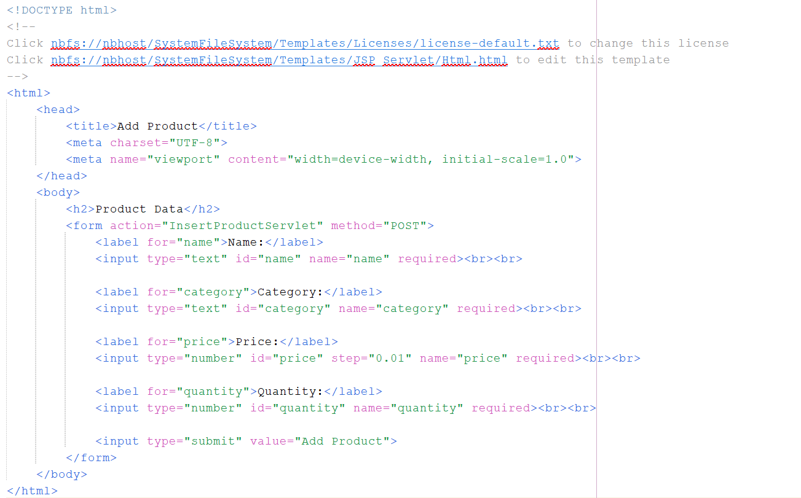

Product.java
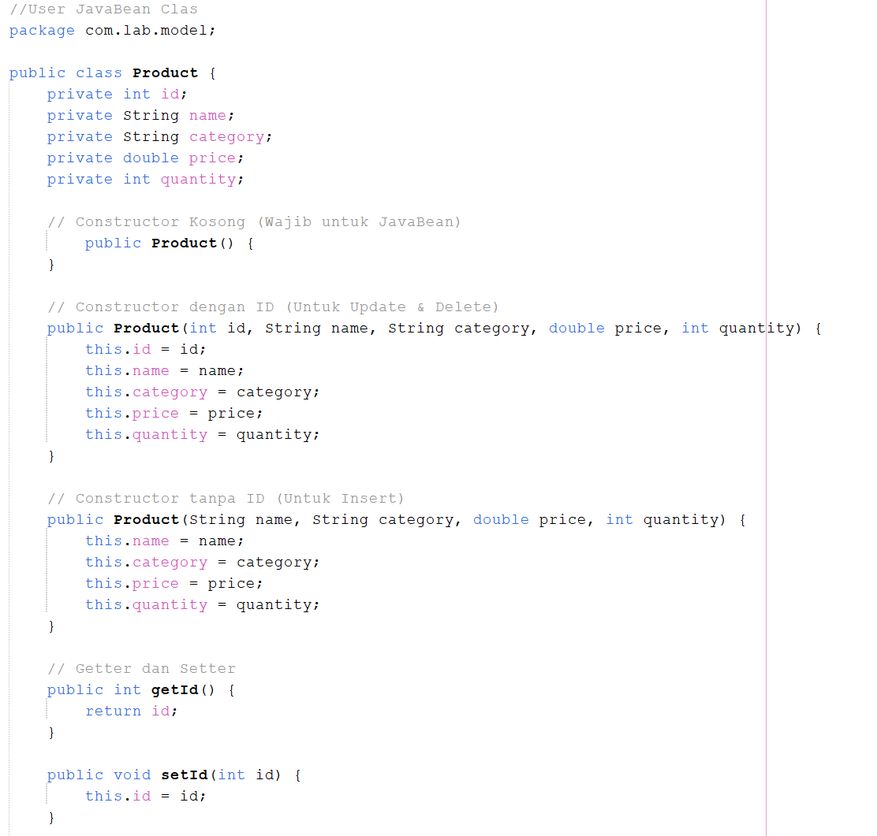
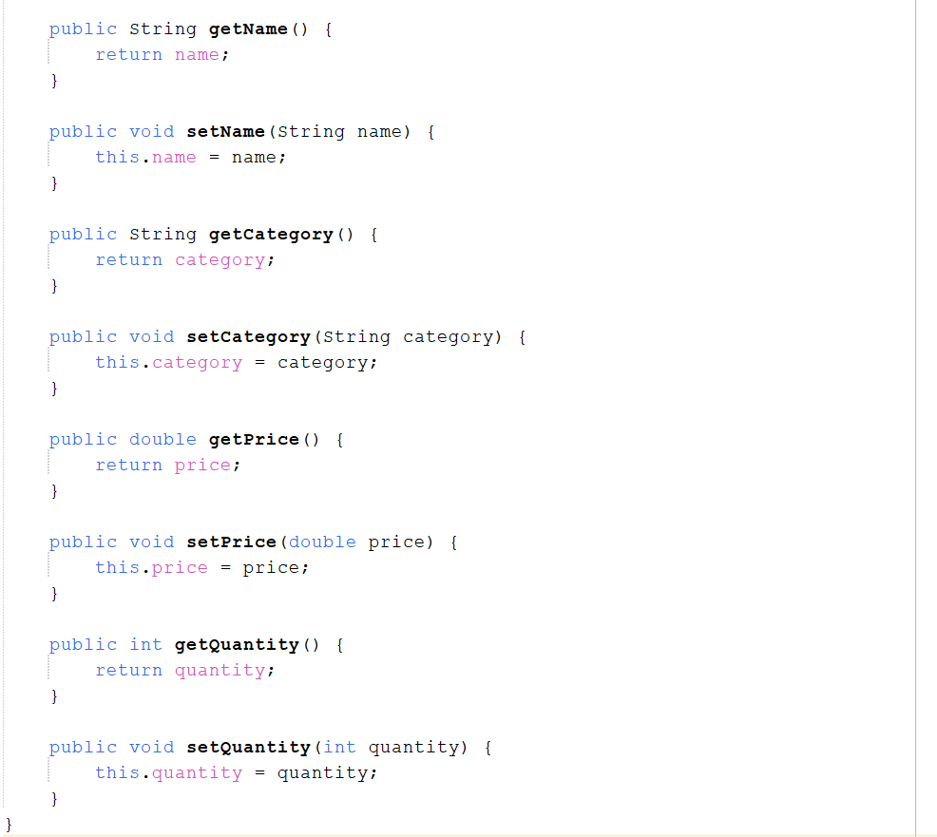

ProductDAO.java
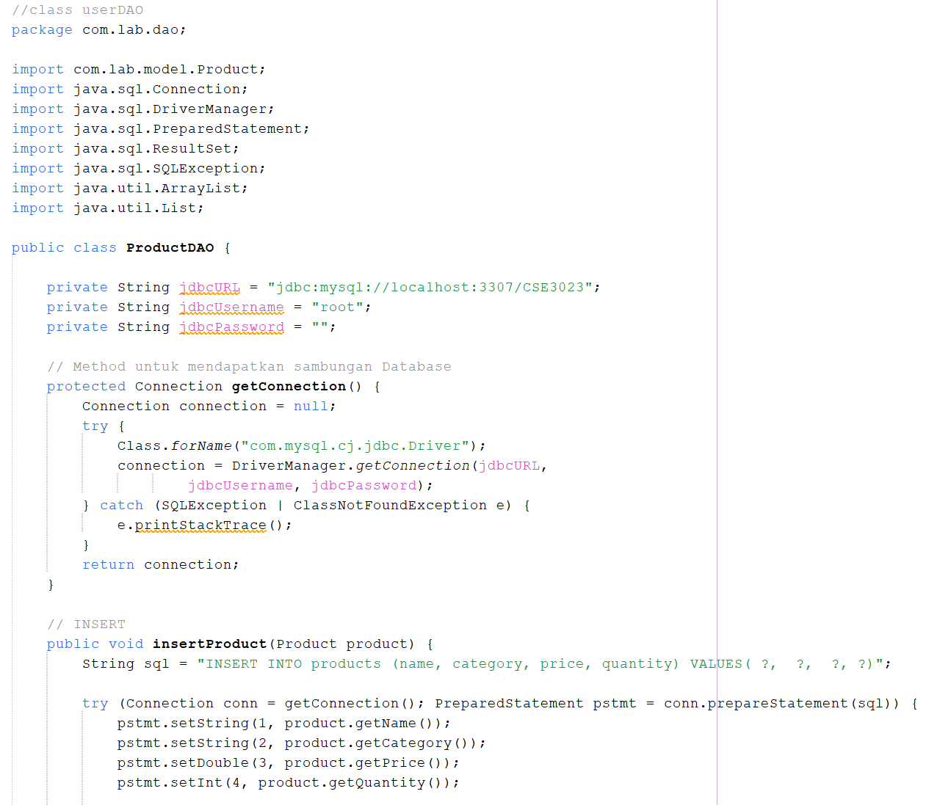
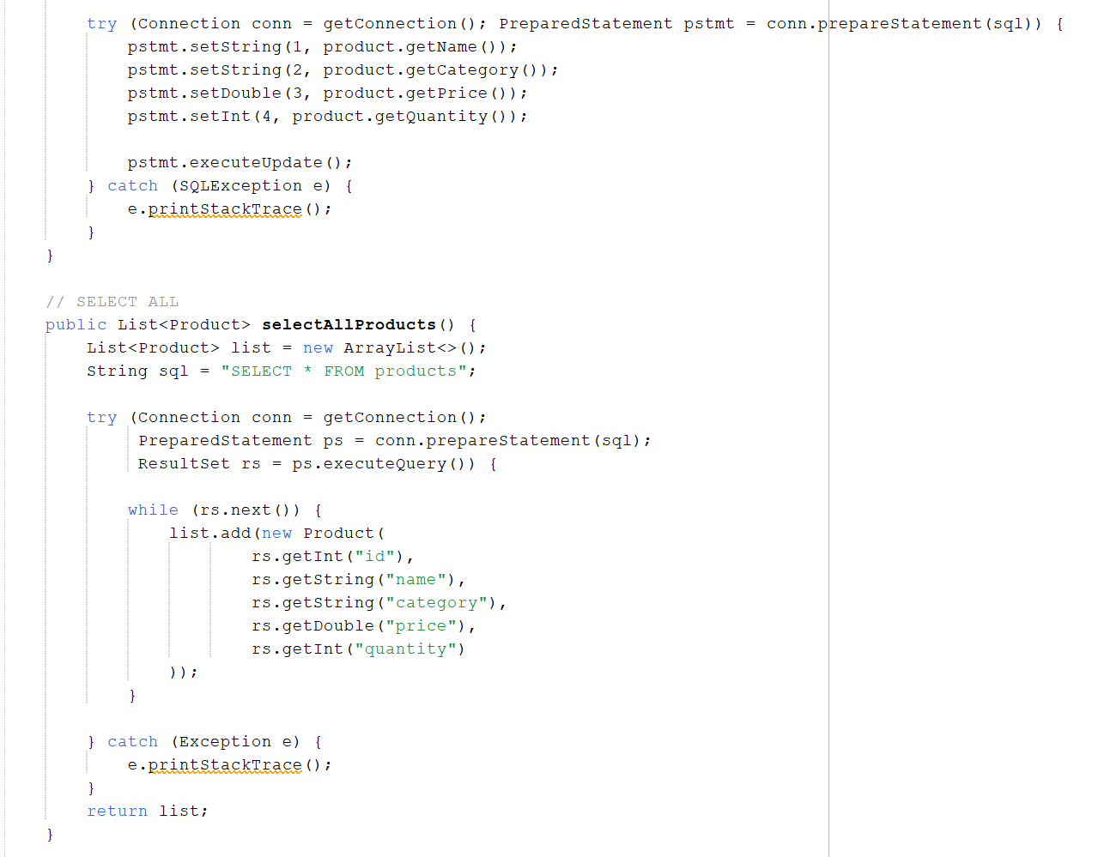
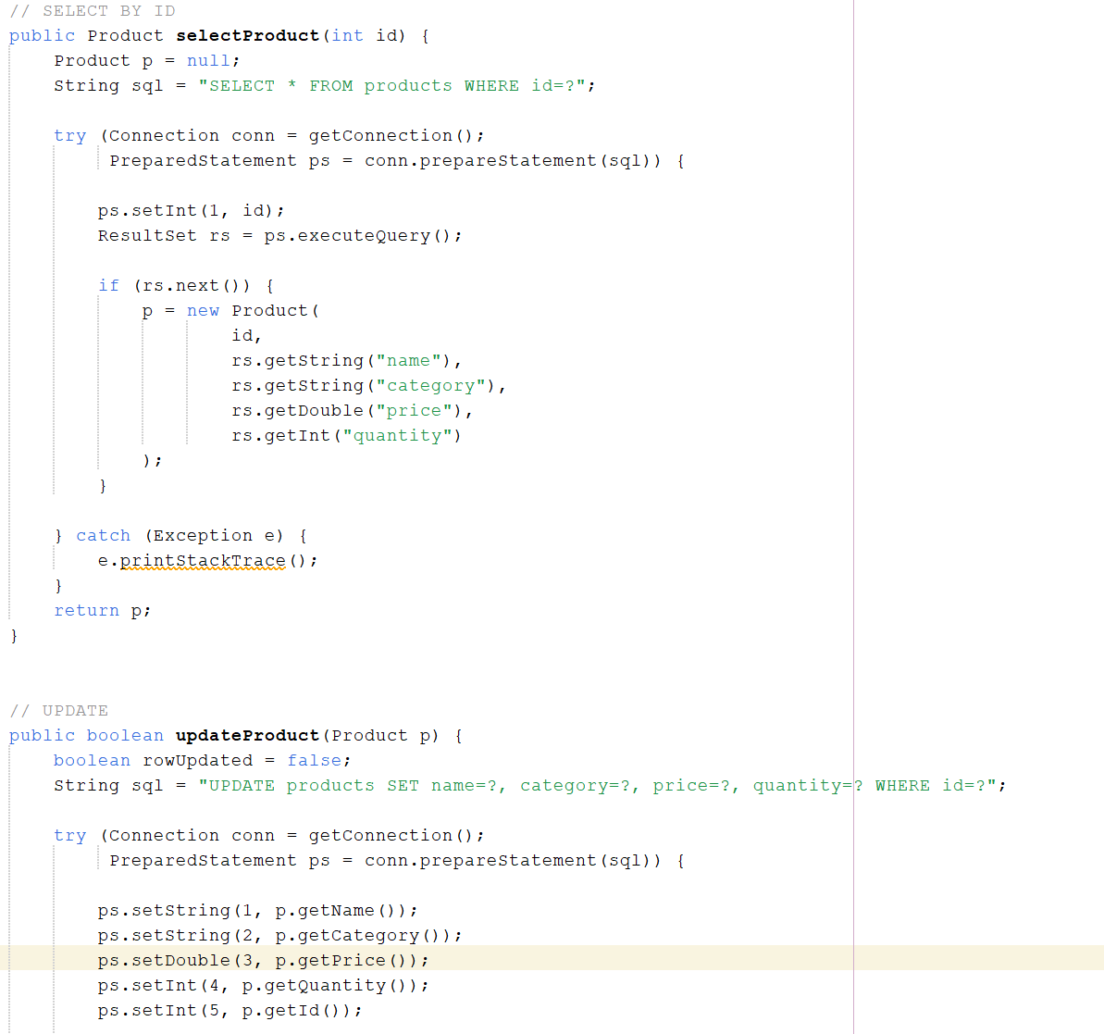
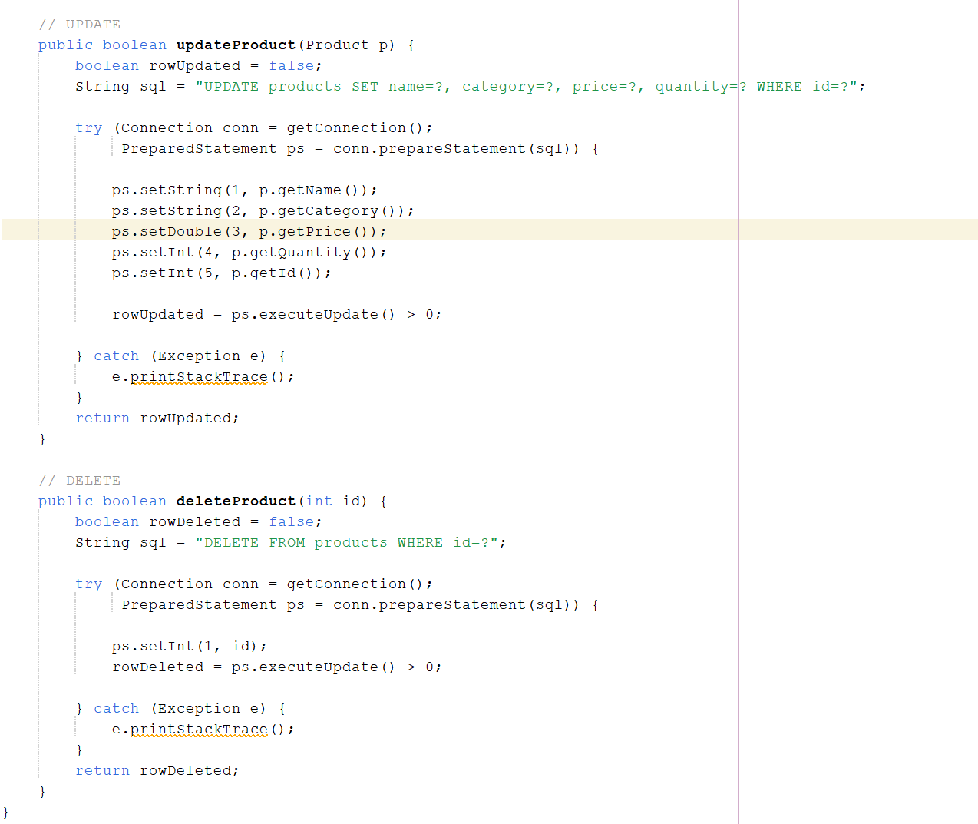

InsertProductServlet.java
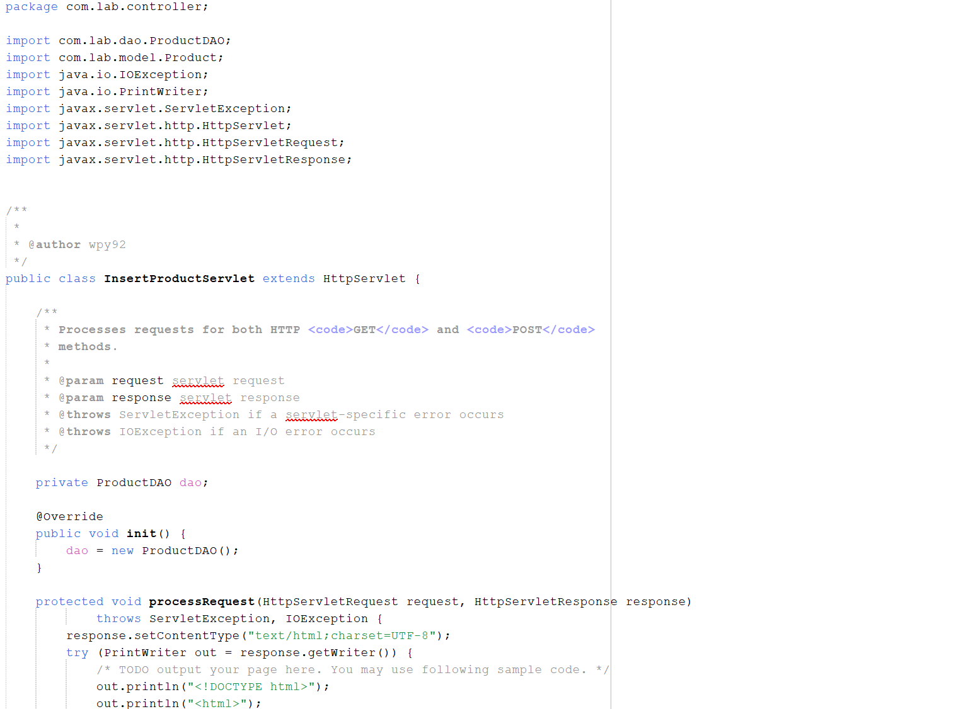
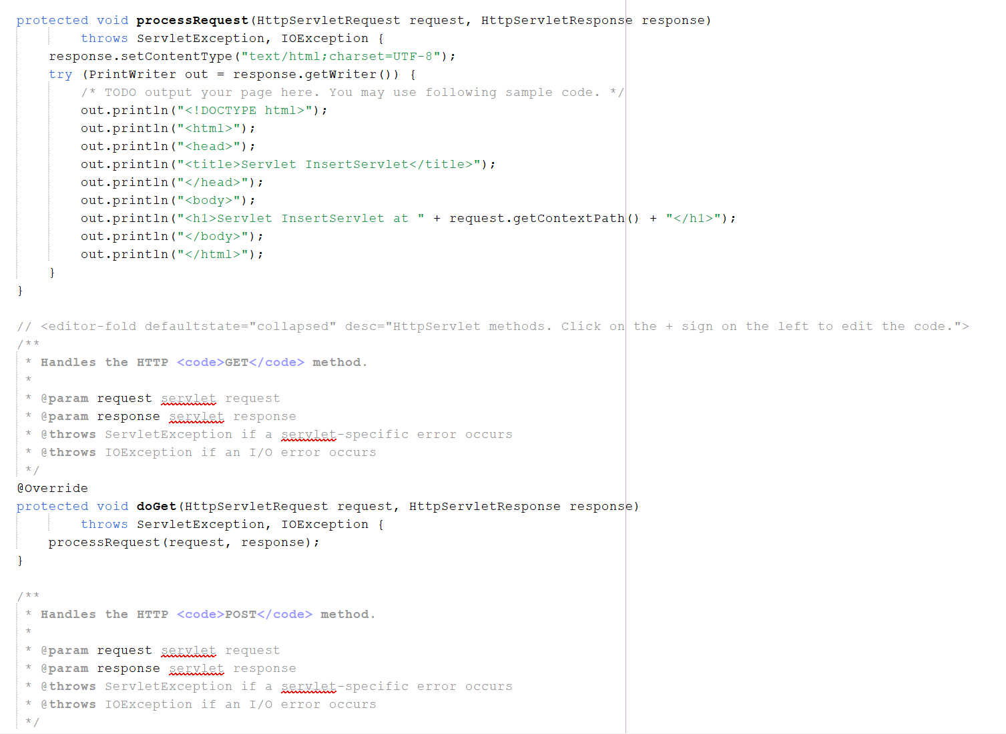
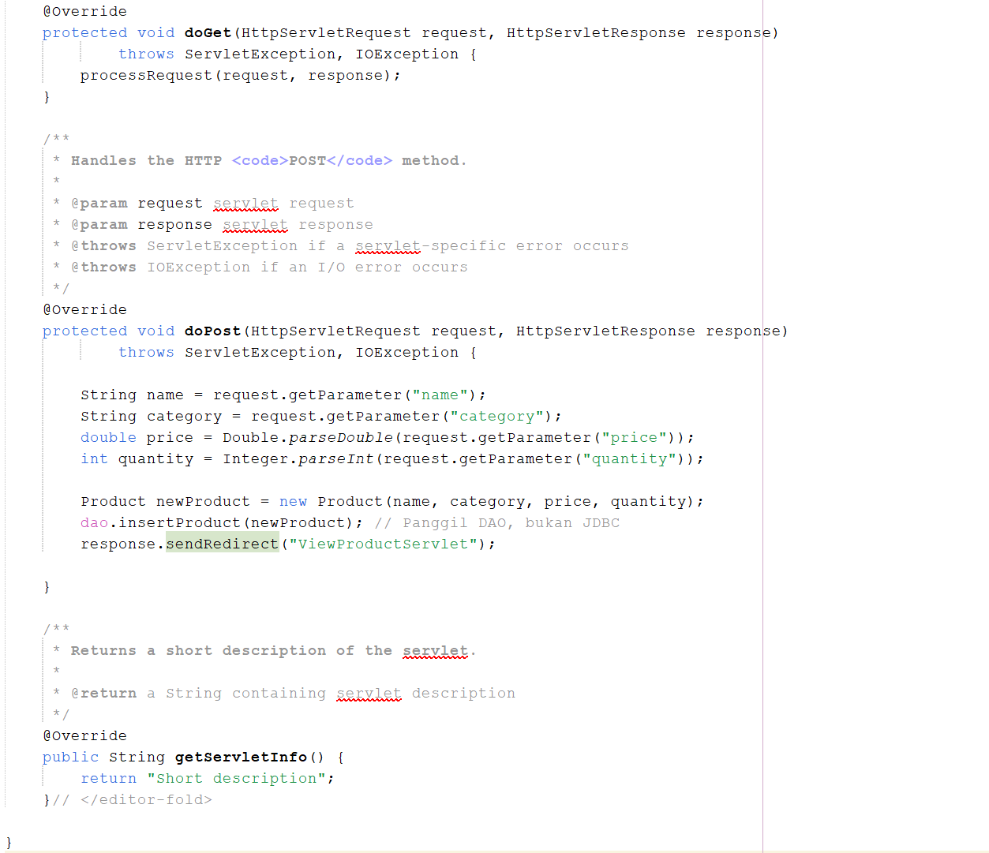

ViewProductServlet.java
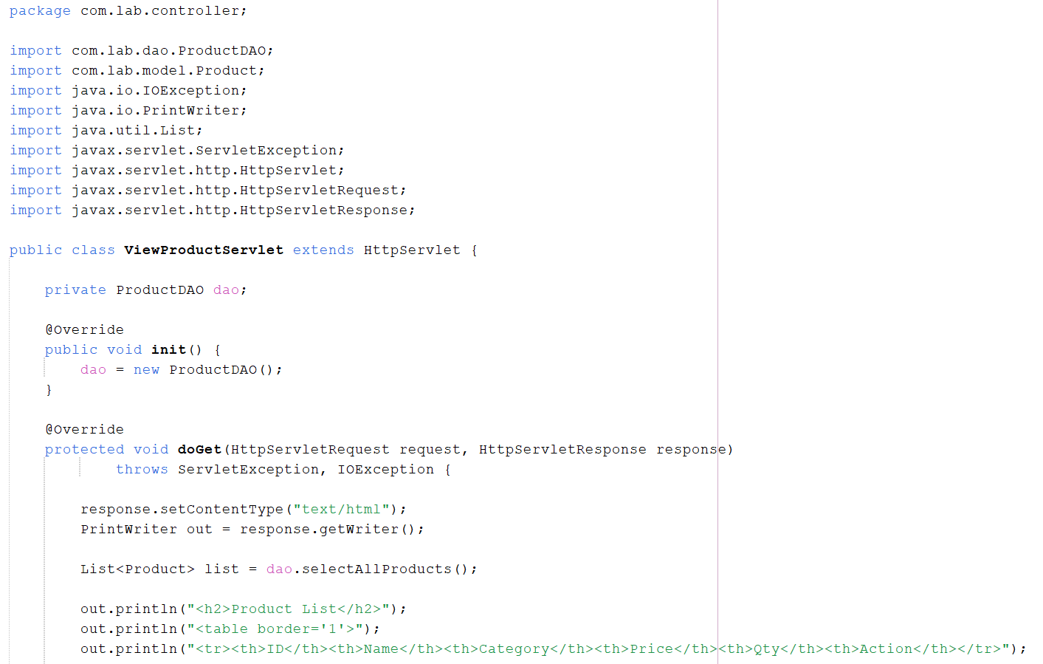
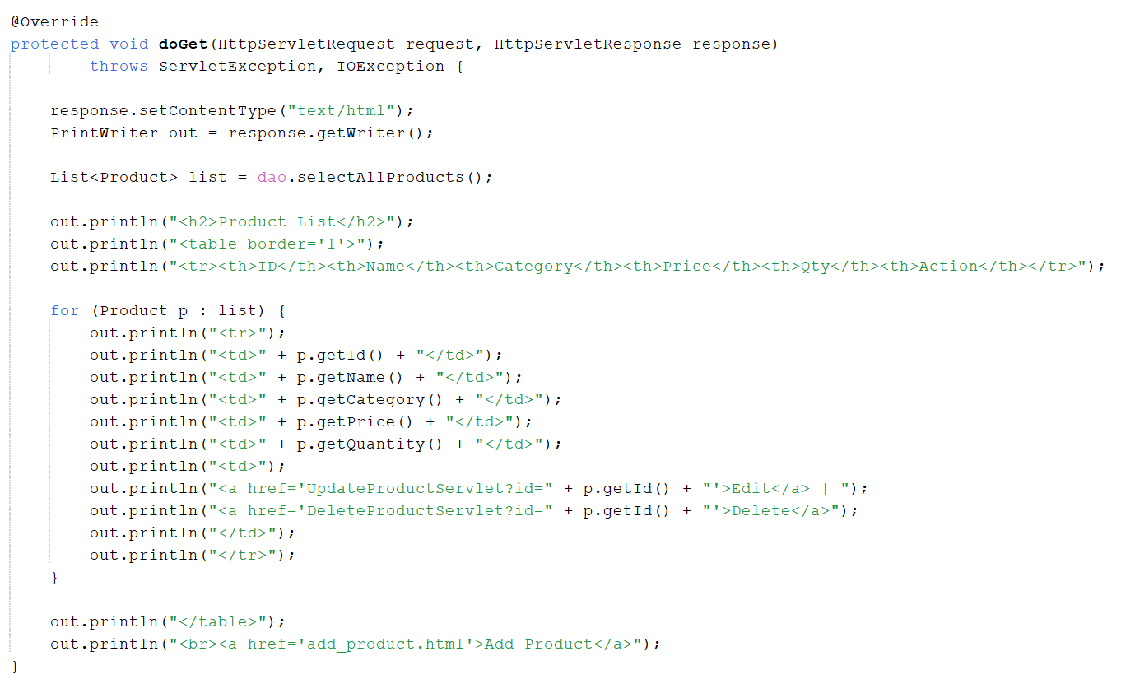
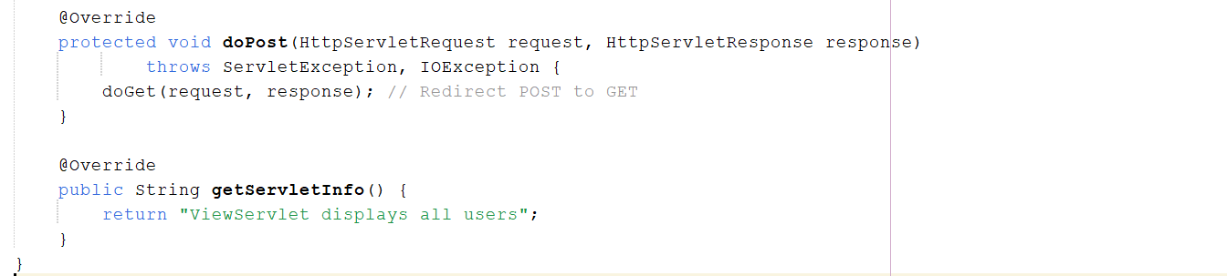

DeleteProductServlet.java
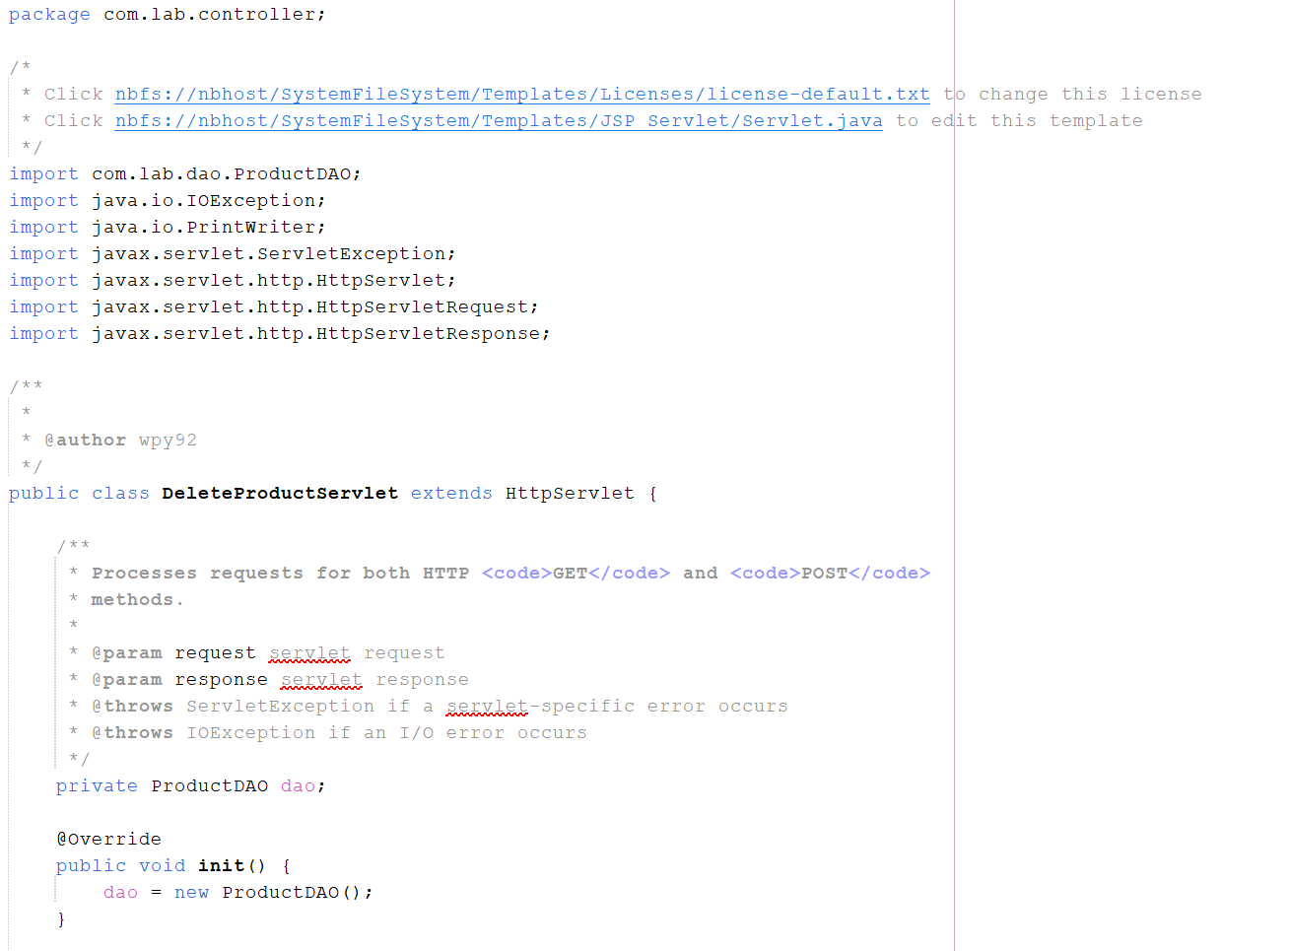
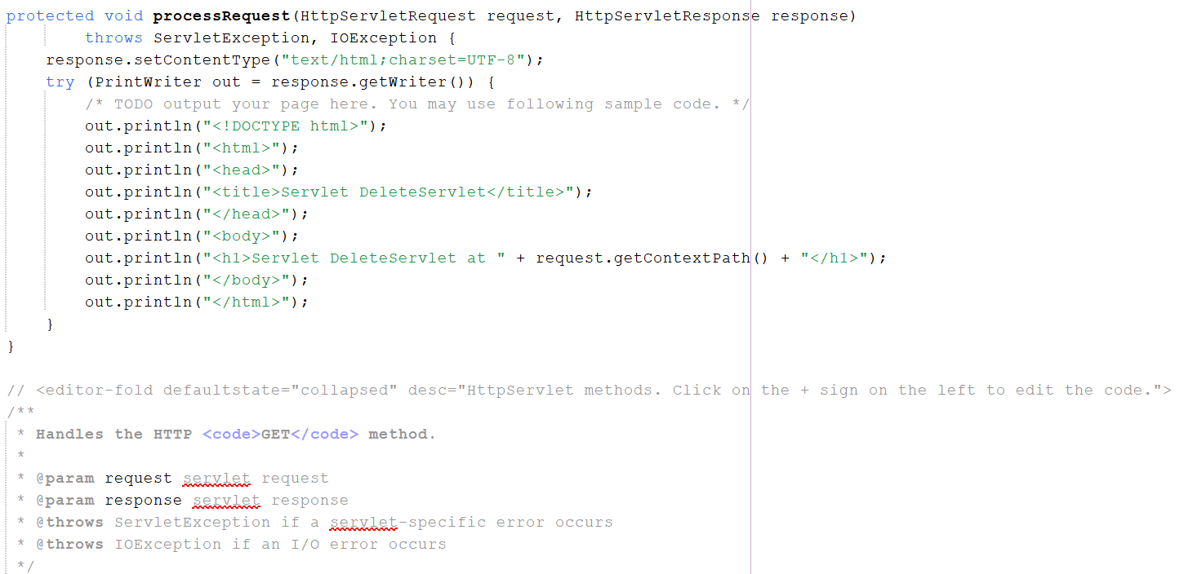
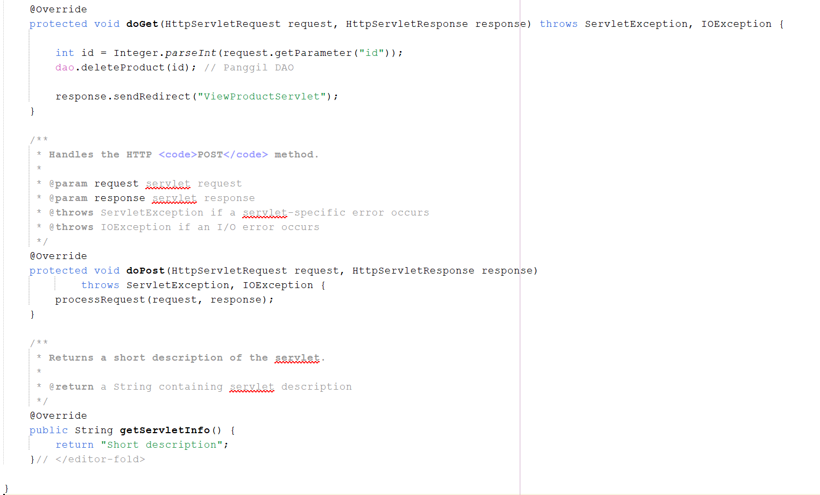

UpdateProductServlet.java
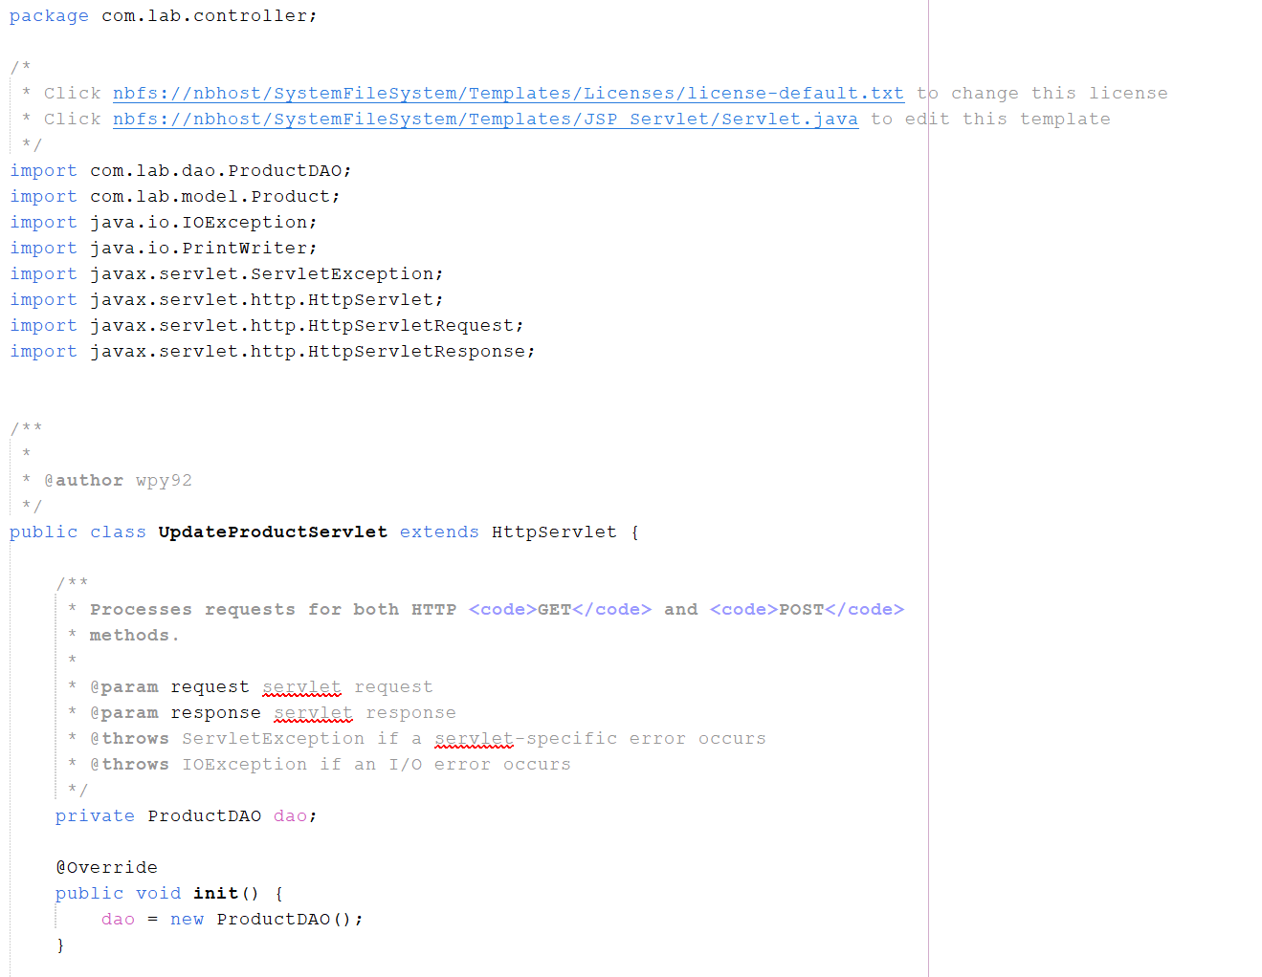
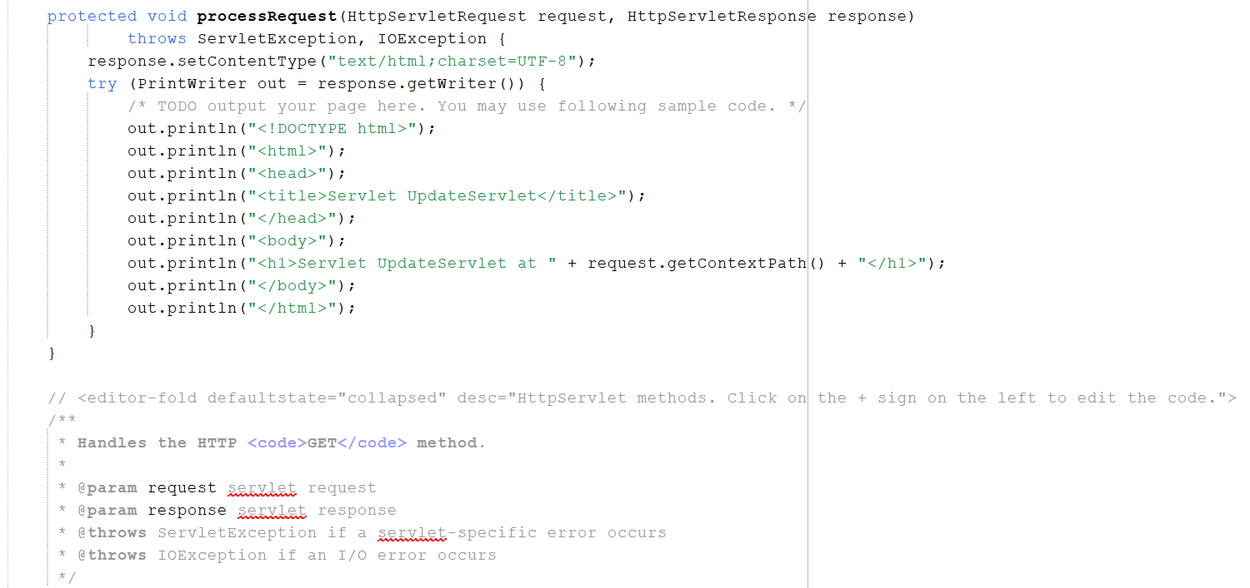
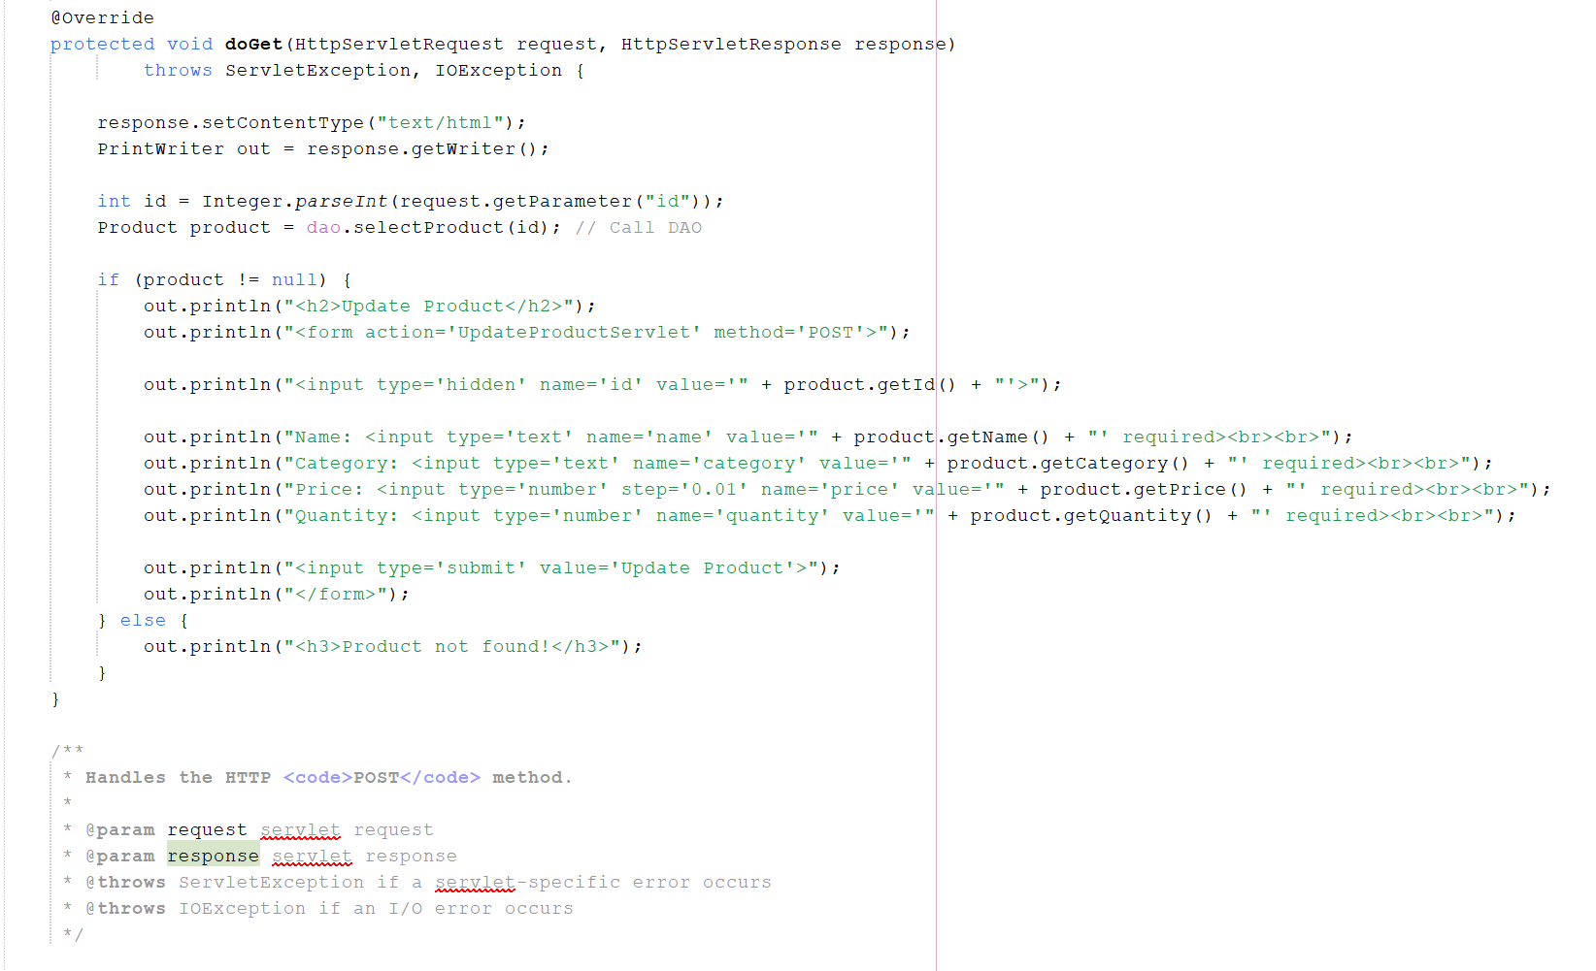
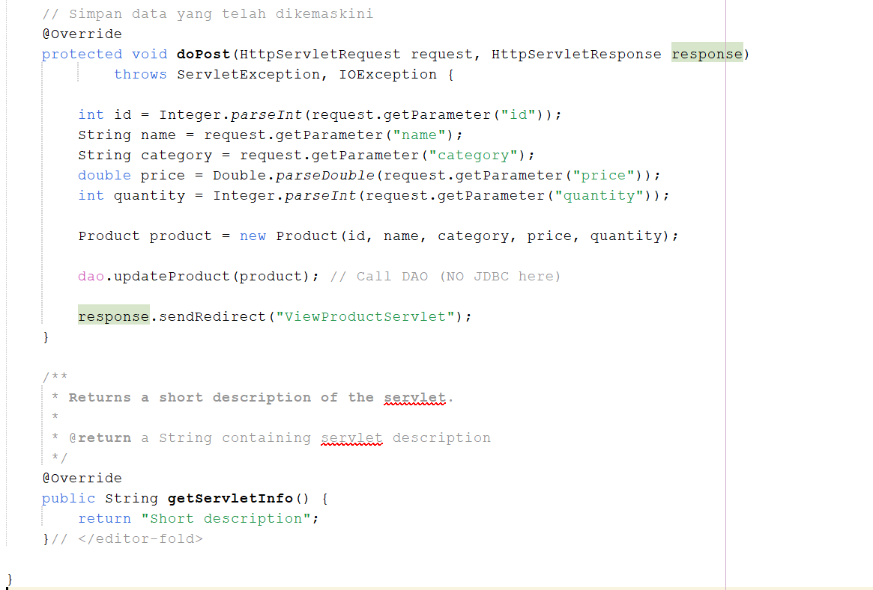

Input:
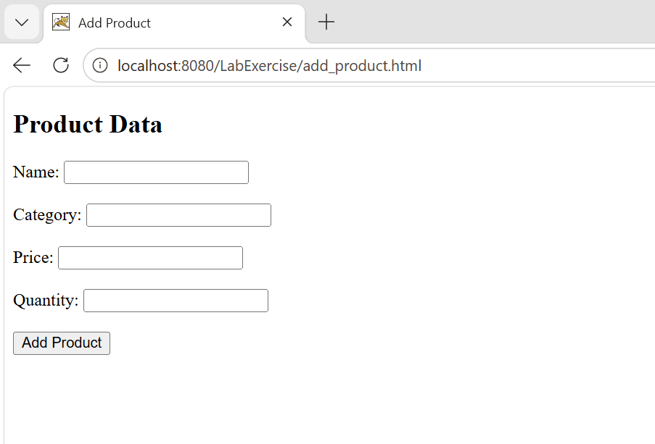

Output:
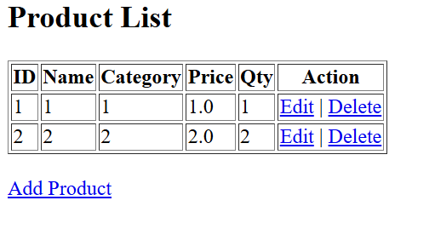

Edit product:
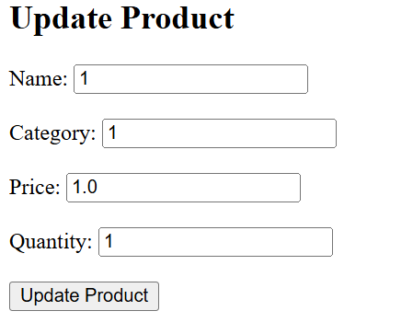

Delete Product:
